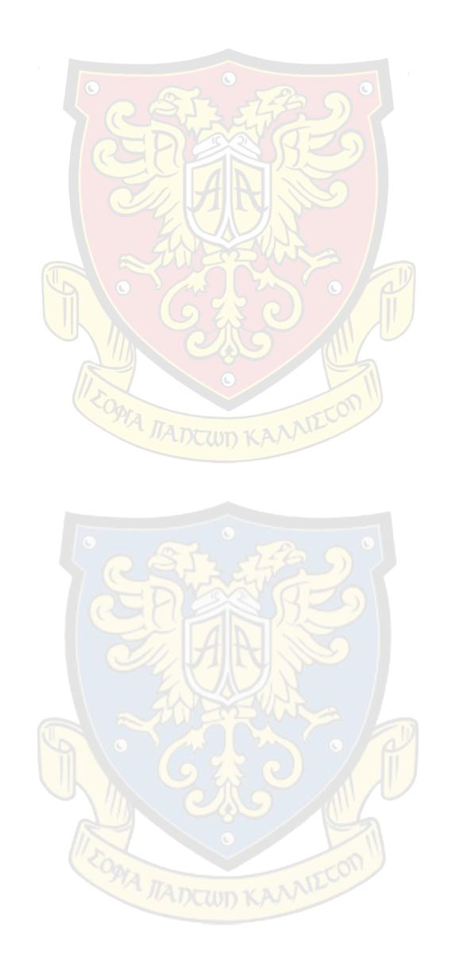
12th March 2020
Re: Global Covid-19 Coronavirus Health Crisis

Dear Parents/Guardians,

With the growing pandemic of the Coronavirus (COVID-19), the Ministry of Education has advised the shutdown of all educational institutes throughout Cyprus, including public and private schools as well as afternoon Institutes.

These precautionary measures are being taken for the ongoing security of our students and their families and will take effect as of tomorrow, Friday 13th of March and will last until the following Friday, 20th of March.

We understand that the closing of the schools coincides with our students’ Mock Exams, and we would like to assure students that we will be pushing our exams and will begin on the 30th of March and will be completed on the last day before Easter holidays, 10th of April.

As for our younger students, we would like to inform parents that due to the week long closure of schools, we have been advised by the Ministry to add an additional week at the end of our Spring Semester.

We will be doing our best to keep you and your families up to date in regards to the Ministry of Education’s decisions as well as any further information released by the Ministry of Health.

In the meantime we would like to reiterate the importance of continued hygiene in all days of daily life, as well as discourage the gathering of groups in closed or open spaces in order to ensure safety for all.

We would like to apologise for any inconvenience and thank you for your understanding.

Yours sincerely,

Samantha Bargilis-Beer
Educational Director

